**Azure Container Instance**

1. Azure Container Instance is nothing but a serverless container running engine. Like only 1 container can be run on it. It is used specifically where no VM, Kubernetes is required. Like a quick static site, or quick API or something really light weight, which is containerized. A perfect example would be a static voting app (which cannot be hosted on other azure services due to cost effectiveness).
2. So, for ACI below things are needed.
   1. ACR 🡪 where you have your image stored
   2. Azure admin role enabled in ACR
3. Now, lets start from basics, in your Linux system or WSL, you need to have docker, which can be installed by command,
   1. sudo snap install docker
   2. docker --version
4. Now you need azure cli installed in your machine, so it can push images in ACR, for that use below commands,
   1. sudo apt update
   2. sudo apt install -y ca-certificates curl apt-transport-https lsb-release gnupg
   3. curl -sL https://packages.microsoft.com/keys/microsoft.asc | sudo gpg --dearmor -o /usr/share/keyrings/microsoft.gpg
   4. echo "deb [arch=amd64 signed-by=/usr/share/keyrings/microsoft.gpg] https://packages.microsoft.com/repos/azure-cli/ $(lsb_release -cs) main" | sudo tee /etc/apt/sources.list.d/azure-cli.list
   5. sudo apt update
   6. sudo apt install -y azure-cli
   7. az –version
5. (OPTIONAL) Now, just for surety run below commands to add your user to access the docker daemon,
   1. sudo groupadd docker
   2. sudo usermod -aG docker $USER
   3. newgrp docker
6. Now pull image from docker and tag it
   1. sudo docker pull nginx:latest
   2. sudo docker tag nginx:latest myadfsf.azurecr.io/nginx:mydev-1
7. Now login to azure and azure acr
   1. az login 🡪 A link will be generated, paste it in web browser and authenticate, then it will automatically log you in through the bash
   2. az acr login --name myadfsf
8. Now push the image in your acr
   1. docker push myadfsf.azurecr.io/nginx:mydev-1
9. It will now create a repo in the acr with your image in it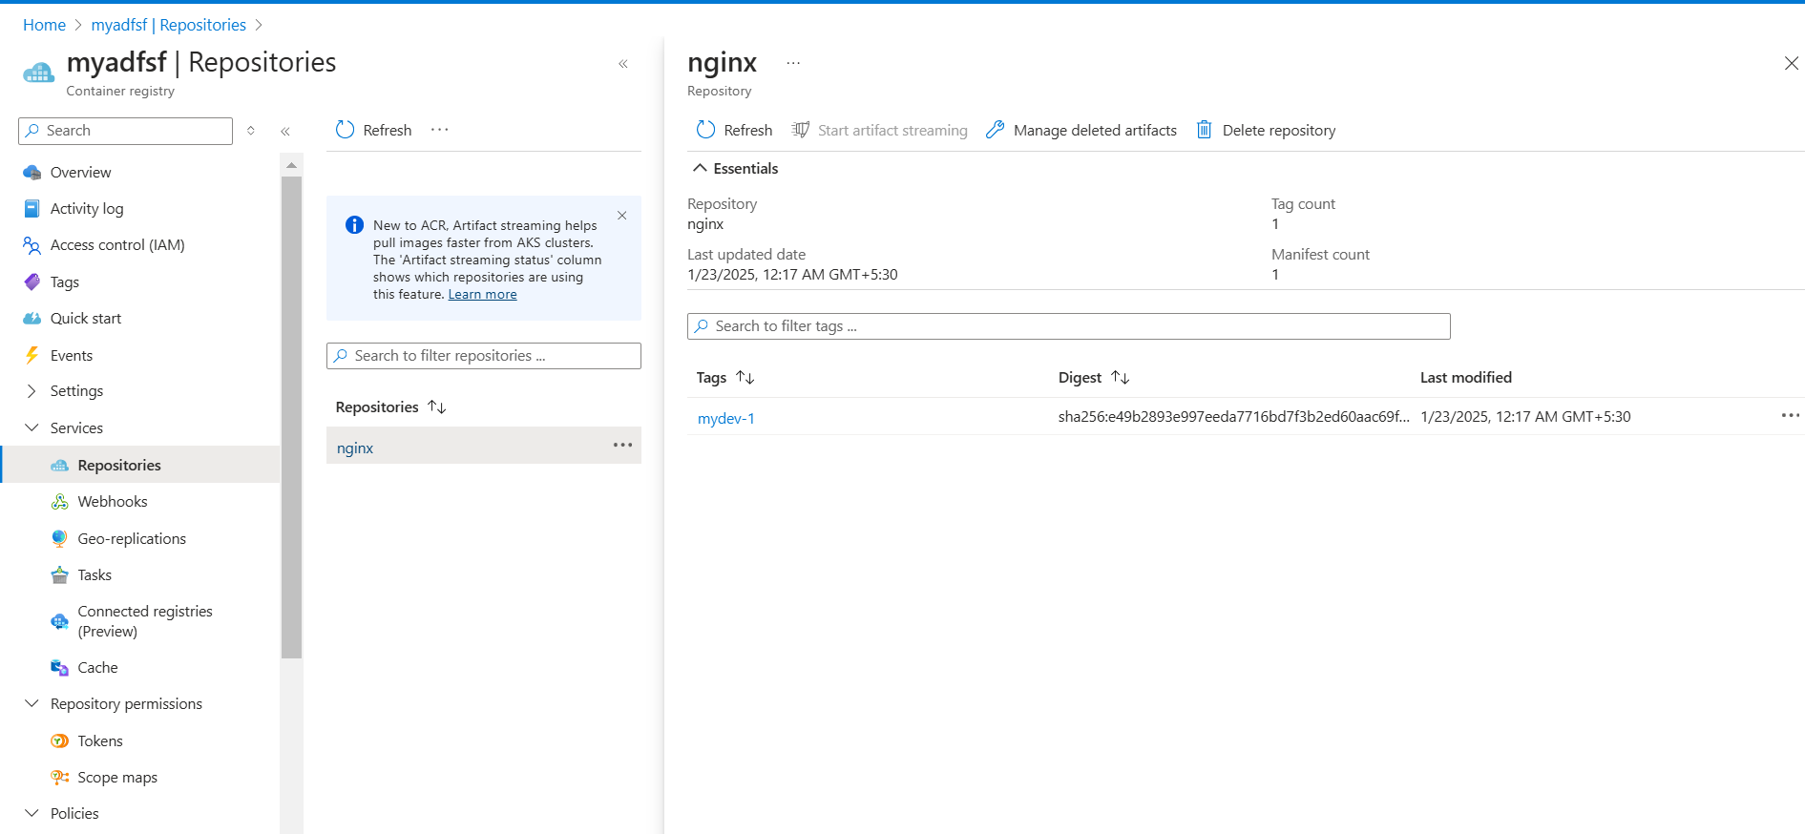
10. The ACI now will fetch the image and run it.
11. As you can see I have got an nginx image, to see its ip, run the below command in you system,
    1. az container show --resource-group primaryDB --name myaci --query "ipAddress.ip" -o tsv 🡪 It will give you the IP
12. Now browse it and voila! (P.S. Azure Container Instance equivalent in AWS is Fargate)